Web Programming Lab - Week 1

Name: Srihari Srinivasan

Date: 07/01/2025

Section: C Roll No: 40

Registration Number: 220905326

1. Write a simple poem and represent it as a web page. Give a title for the poem.

Make rhyming words in the poem as bold

**HTML:**

<!DOCTYPE html>

<meta charset="UTF-8">

<html>

<title>My poem</title>

<h1>My poem</h1>

<body>

<p>Across the floor there runs a <b>mouse</b></p>

<p>The quietest sound you ever <b>heard</b></p>

<p>Yet heard throughout the great old <b>house!</b></p>

<p>Although no louder than a <b>bird.</b></p>

</body>

</html>

**OUTPUT:**



1. Assume you have brought a new car. Write down the list of additional

accessories you need for the car as an unordered list in HTML. Also, list the

travel plans on the car as an ordered list.

**HTML:**

<!DOCTYPE html>

<meta charset="UTF-8">

<html>

<title>Car Accessories</title>

<body>

<div>

<h1>My New Car</h1>

<img src="car.jpeg" alt="Car Image">

</div>

<br/>

<div>

<h2>Car Accessories</h2>

<ul>

<li>Seat Covers</li>

<li>Sun Blinds</li>

<li>Floor Mats</li>

<li>Decals</li>

</ul>

</div>

<br/>

<div>

<h2>Travel Plans</h2>

<ol>

<li>Sagharika Gardens</li>

<li>Panni House</li>

<li>Pondicherry</li>

<li>Croc Villa</li>

</ol>

</div>

</body>

</html>

**OUTPUT:**

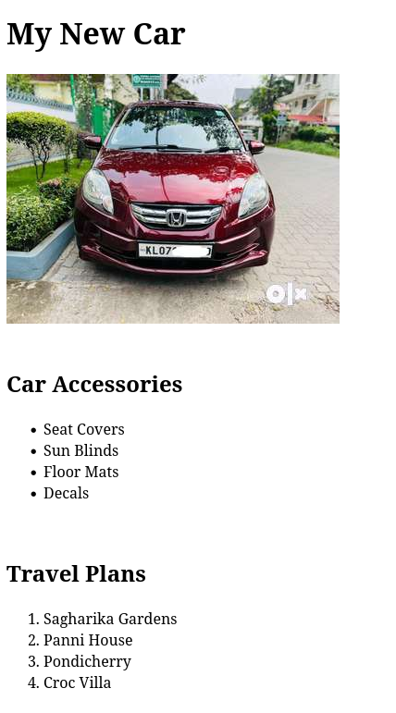

1. Make a website titled “Share your Winter Vacation Videos”

**HTML:**

<!DOCTYPE html>

<html lang="en">

<head>

<meta charset="UTF-8" />

<meta name="viewport" content="width=device-width, initial-scale=1.0" />

<title>Share Your Winter Vacation Videos</title>

<style>

body {

font-family: Arial, sans-serif;

background: linear-gradient(

to bottom,

#4a3c8c,

#a8a3e3,

#d8d4f7

);

color: white;

text-align: center;

margin: 0;

padding: 0;

}

header {

background: #333;

padding: 10px 0;

color: white;

font-size: 24px;

font-weight: bold;

text-transform: uppercase;

text-align: center;

margin-bottom: 20px;

}

.videos-container {

display: flex;

justify-content: center;

gap: 20px;

padding: 20px;

}

.video-card {

background: white;

border-radius: 5px;

padding: 10px;

box-shadow: 0 4px 8px rgba(0, 0, 0, 0.2);

color: black;

width: 300px;

}

video {

width: 100%;

border-radius: 5px;

}

.video-card p {

margin: 10px 0 0;

font-size: 14px;

text-align: center;

}

</style>

</head>

<body>

<header>Share Your Winter Vacation Videos</header>

<div class="videos-container">

<div class="video-card">

<video controls>

<source src="Media/video1.mp4" type="video/mp4" />

Your browser does not support the video tag.

</video>

<p>Winter Travel - Destination 1</p>

</div>

<div class="video-card">

<video controls>

<source src="Media/video2.mp4" type="video/mp4" />

Your browser does not support the video tag.

</video>

<p>Winter Travel - Destination 2</p>

</div>

<div class="video-card">

<video controls>

<source src="Media/video3.mp4" type="video/mp4" />

Your browser does not support the video tag.

</video>

<p>Winter Travel - Destination 3</p>

</div>

</div>

</body>

</html>

**OUTPUT:**

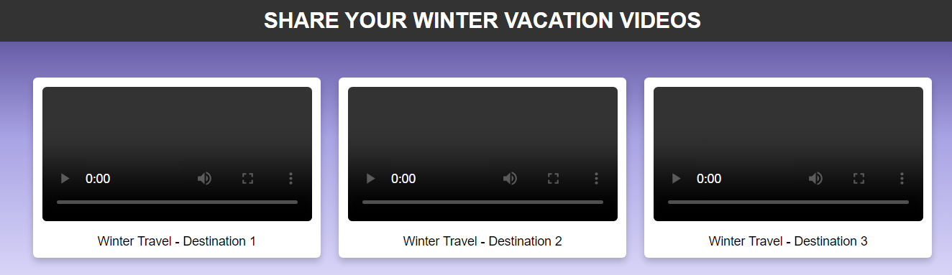

1. Create the following output in HTML

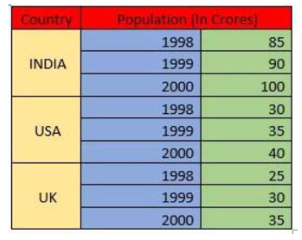

**HTML:**

<!DOCTYPE html>

<meta charset="UTF-8">

<link rel="stylesheet" href="p4style.css">

<html>

<title>Table</title>

<body>

<table>

<thead>

<th bgcolor="red">Country</th>

<th bgcolor="red" colspan=2>Population (In Crores)</th>

</thead>

<tr>

<td class="alcenter" rowspan=3>INDIA</td>

<td class="alright lightblue">1998</td>

<td class="alright">85</td>

</tr>

<tr>

<td class="alright lightblue">1999</td>

<td class="alright">90</td>

</tr>

<tr>

<td class="alright lightblue">2000</td>

<td class="alright">100</td>

</tr>

<tr>

<td class="alcenter" rowspan=3>USA</td>

<td class="alright lightblue">1998</td>

<td class="alright">30</td>

</tr>

<tr>

<td class="alright lightblue">1999</td>

<td class="alright">35</td>

</tr>

<tr>

<td class="alright lightblue">2000</td>

<td class="alright">40</td>

</tr>

<tr>

<td class="alcenter" rowspan=3>UK</td>

<td class="alright lightblue">1998</td>

<td class="alright">25</td>

</tr>

<tr>

<td class="alright lightblue">1999</td>

<td class="alright">30</td>

</tr>

<tr>

<td class="alright lightblue">2000</td>

<td class="alright">35</td>

</tr>

</table>

</body>

</html>

**CSS:**

table, th, td {

border: 1px solid black;

border-collapse: collapse;

padding: 3px;

}

.alright {

text-align: right;

background: lightgreen;

}

.alcenter {

text-align: center;

background: lightyellow;

}

.lightblue {

background: lightblue;

}

**OUTPUT:**

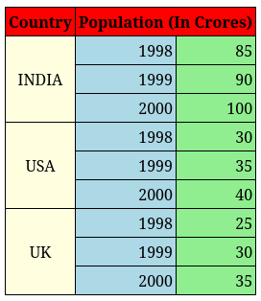

1. Create an array of Javascript objects for the data in question 4 and display

each row in the table form through Javascript code.

**HTML:**

<!DOCTYPE html>

<html lang="en">

<head>

<meta charset="UTF-8">

<title>Table</title>

<link rel="stylesheet" href="p4style.css">

</head>

<body>

<h2>Population Data</h2>

<div id="table-container"></div>

<script type="text/javascript">

const popData = [

{ country: 'INDIA', year: 1998, population: 85 },

{ country: 'INDIA', year: 1999, population: 90 },

{ country: 'INDIA', year: 2000, population: 100 },

{ country: 'USA', year: 1998, population: 30 },

{ country: 'USA', year: 1999, population: 35 },

{ country: 'USA', year: 2000, population: 40 },

{ country: 'UK', year: 1998, population: 25 },

{ country: 'UK', year: 1999, population: 30 },

{ country: 'UK', year: 2000, population: 35 }

];

function displayTable(data) {

let tableHTML = '<table><thead><tr>';

tableHTML += '<th bgcolor="red">Country</th>';

tableHTML += '<th bgcolor="red" colspan="2">Population (In Crores)</th>';

tableHTML += '</tr></thead><tbody>';

let currentCountry = '';

let rowCount = 0;

data.forEach((row, index) => {

if (row.country !== currentCountry) {

if (currentCountry !== '') {

tableHTML += '</tr>';

}

currentCountry = row.country;

tableHTML += `<tr><td class="alcenter" rowspan="3">${row.country}</td><td class="alright lightblue">${row.year}</td><td class="alright">${row.population}</td></tr>`;

} else {

tableHTML += `<tr><td class="alright lightblue">${row.year}</td><td class="alright">${row.population}</td></tr>`;

}

});

tableHTML += '</tbody></table>';

document.getElementById('table-container').innerHTML = tableHTML;

}

displayTable(popData);

</script>

</body>

</html>

**CSS:**

table, th, td {

border: 1px solid black;

border-collapse: collapse;

padding: 3px;

}

.alright {

text-align: right;

background: lightgreen;

}

.alcenter {

text-align: center;

background: lightyellow;

}

.lightblue {

background: lightblue;

}

**OUTPUT:**

